

**DELHI PUBLIC SCHOOL, DEHRADUN**

**SESSION 2020-21**

**PYTHYON**

**PROJECT FILE ON**

***“TRAVEL AGENCY BOOKING AND MANAGEMENT SYSTEM”***

**PROJECT PREPARED BY:**

**Vanshaj Raghuvanshi and Ayush Chauhan**

**Class: XII A**

**Roll No.:**

**Session: 2020-2021**

**Delhi Public School, Dehradun**

**TABLE OF CONTENTS**

* **Certificate**
* **Acknowledgement**
* **Libraries/ Modules and their purpose**
* **Coding**
* **Output Screens**
* **Limitations**
* **Requirements**
* **Bibliography**



**DEPARTMENT OF COMPUTER SCIENCE**

**DELHI PUBLIC SCHOOL, DEHRADUN**

***CERTIFICATE***

This is to certify that the original and genuine investigation content of this project entitled **“TRAVEL AGENCY BOOKING AND MANAGEMENT SYSTEM”** has been satisfactorily executed and prepared by **VANSHAJ RAGHUVANSHI AND AYUSH CHAUHAN**, a student of class **CLASS 12 A,** under the direct supervision of Dr. Pooja Vashishta (Subject Teacher) for the academic session 2020-2021. This bonafide work of his/her, has been submitted to **DELHI PUBLIC SCHOOL, DEHRADUN**, for consideration in partial fulfillment of **Computer Science Practical Examination** conducted by AISSCE, New Delhi.

The project report is upto the expectation and a result of his/her efforts and endeavors.

**INTERNAL EXAMINER EXTERNAL EXAMINER**

**PRINCIPAL**

***ACKNOWLEDGEMENT***

Project is like a bridge between theoretical and practical learning and now on the accomplishment of this project successfully, I would like to thank all the people who have been concerned with it and bestowed upon me their blessings and the heart pledged support.

Primarily, I would like to thank God, who always guided me to work on the right path of life. Without his grace this project could not become a reality. Next to him are my parents, to whom I am greatly indebted for their love and encouragement to this stage.

I am feeling highly obliged in taking the opportunity to express my special thanks and gratitude to our Respected Principal Sir, Mr. B. K. Singh and Vice-Principal Ma’am, Mrs. Sujata Singh, for their valuable guidance, keen interest and encouragement.

I express my deep and sincere gratitude to my subject teacher Dr. Pooja Vashishta, whose guidance, encouragement, suggestions and constructive criticism have contributed immensely to the evolution of my ideas on the project.

At last but not the least, I am thankful to all my teachers and friends who have been always helped me and encouraged me throughout the year. No more I have the words to express my thanks, but my heart is still full of favours received from every person.

**MODULES USED**

1. **pricecalc.py:-**

**To calculate the payable amount**

***CODING:-***

def state_price(s,t,star,d): #s= name od state, t= mode of transport, star= no of star hotel, d= no of days

price=0

fee=0

if s=="Bihar":

a=2000

price+=a

if t=="Flight":

fare=2000

price+=fare

elif t=="Bus":

fare=1100

price+=fare

elif t=="Train":

fare=1300

price+=fare

else:

print("Invalid Option")

if star=="2":

hprice= 800

stay=int(d)*hprice

fee+=stay

elif star=="3":

hprice=1300

stay=int(d)*hprice

fee+=stay

elif star=="4":

hprice=1800

stay=int(d)*hprice

fee+=stay

else:

print("Invalid Option")

elif s=="Chhattisgarh":

a=1800

price+=a

if t=="Flight":

fare=1800

price+=fare

elif t=="Bus":

fare=1000

price+=fare

elif t=="Train":

fare=1200

price+=fare

else:

print("Invalid Option")

if star=="2":

hprice= 1000

stay=int(d)*hprice

fee+=stay

elif star=="3":

hprice=1300

stay=int(d)*hprice

fee+=stay

elif star=="4":

hprice=1500

stay=int(d)*hprice

fee+=stay

else:

print("Invalid Option")

elif s=="Gujarat":

a=700

price+=a

if t=="Flight":

fare=1000

price+=fare

elif t=="Bus":

fare=600

price+=fare

elif t=="Train":

fare=900

price+=fare

else:

print("Invalid Option")

if star=="2":

hprice= 900

stay=int(d)*hprice

fee+=stay

elif star=="3":

hprice=1200

stay=int(d)*hprice

fee+=stay

elif star=="4":

hprice=1350

stay=int(d)*hprice

fee+=stay

else:

print("Invalid Option")

elif s=="Maharashtra":

a=3000

price+=a

if t=="Flight":

fare=2000

price+=fare

elif t=="Bus":

fare=1300

price+=fare

elif t=="Train":

fare=1600

price+=fare

else:

print("Invalid Option")

if star=="2":

hprice= 1000

stay=int(d)*hprice

fee+=stay

elif star=="3":

hprice=1250

stay=int(d)*hprice

fee+=stay

elif star=="4":

hprice=1600

stay=int(d)*hprice

fee+=stay

else:

print("Invalid Option")

elif s=="Madhya Pradesh":

a=2500

price+=a

if t=="Flight":

fare=2000

price+=fare

elif t=="Bus":

fare=1400

price+=fare

elif t=="Train":

fare=1700

price+=fare

else:

print("Invalid Option")

if star=="2":

hprice= 800

stay=int(d)*hprice

fee+=stay

elif star=="3":

hprice=1100

stay=int(d)*hprice

fee+=stay

elif star=="4":

hprice=1400

stay=int(d)*hprice

fee+=stay

else:

print("Invalid Option")

elif s=="Uttar Pradesh":

a=1700

price+=a

if t=="Flight":

fare=1600

price+=fare

elif t=="Bus":

fare=900

price+=fare

elif t=="Train":

fare=1100

price+=fare

else:

print("Invalid Option")

if star=="2":

hprice= 900

stay=int(d)*hprice

fee+=stay

elif star=="3":

hprice=1150

stay=int(d)*hprice

fee+=stay

elif star=="4":

hprice=1400

stay=int(d)*hprice

fee+=stay

else:

print("Invalid Option")

elif s=="Haryana":

a=1900

price+=a

if t=="Flight":

fare=2100

price+=fare

elif t=="Bus":

fare=1100

price+=fare

elif t=="Train":

fare=1500

price+=fare

else:

print("Invalid Option")

if star=="2":

hprice= 600

stay=int(d)*hprice

fee+=stay

elif star=="3":

hprice=1200

stay=int(d)*hprice

fee+=stay

elif star=="4":

hprice=1500

stay=int(d)*hprice

fee+=stay

else:

print("Invalid Option")

elif s=="Punjab":

a=2000

price+=a

if t=="Flight":

fare=2050

price+=fare

elif t=="Bus":

fare=1150

price+=fare

elif t=="Train":

fare=1500

price+=fare

else:

print("Invalid Option")

if star=="2":

hprice= 1000

stay=int(d)*hprice

fee+=stay

elif star=="3":

hprice=1300

stay=int(d)*hprice

fee+=stay

elif star=="4":

hprice=1600

stay=int(d)*hprice

fee+=stay

else:

print("Invalid Option")

elif s=="Himachal Pradesh":

a=2150

price+=a

if t=="Flight":

fare=2000

price+=fare

elif t=="Bus":

fare=1100

price+=fare

elif t=="Train":

fare=1300

price+=fare

else:

print("Invalid Option")

if star=="2":

hprice= 700

stay=int(d)*hprice

fee+=stay

elif star=="3":

hprice=1400

stay=int(d)*hprice

fee+=stay

elif star=="4":

hprice=1700

stay=int(d)*hprice

fee+=stay

else:

print("Invalid Option")

elif s=="Uttarakhand":

a=2100

price+=a

if t=="Flight":

fare=2000

price+=fare

elif t=="Bus":

fare=1000

price+=fare

elif t=="Train":

fare=1200

price+=fare

else:

print("Invalid Option")

if star=="2":

hprice= 800

stay=int(d)*hprice

fee+=stay

elif star=="3":

hprice=1300

stay=int(d)*hprice

fee+=stay

elif star=="4":

hprice=1800

stay=int(d)*hprice

fee+=stay

else:

print("Invalid Option")

elif s=="New Delhi":

a=1700

price+=a

if t=="Flight":

fare=1800

price+=fare

elif t=="Bus":

fare=700

price+=fare

elif t=="Train":

fare=1200

price+=fare

else:

print("Invalid Option")

if star=="2":

hprice= 900

stay=int(d)*hprice

fee+=stay

elif star=="3":

hprice=1400

stay=int(d)*hprice

fee+=stay

elif star=="4":

hprice=1800

stay=int(d)*hprice

fee+=stay

else:

print("Invalid Option")

else:

print("Sorry, we currently don't offer our services in your state")

tot_price=fee+price

return tot_price

1. **show.py:-**

**Functions defined for data retrieval of entered records, and partner transport agencies and hotels**

***CODING:-***

import mysql.connector

from tkinter import *

x="localhost"

y="root"

z="vanshaj"

mydb = mysql.connector.connect(host=x,user=y,passwd=z)

mydb = mysql.connector.connect(host=x,user=y,passwd=z,database="travel")

mycursor = mydb.cursor()

def showall():

cmd="SELECT * FROM customer"

mycursor.execute(cmd)

S=mycursor.fetchall()

print("="*161)

F="%14s%14s%14s%14s%14s"

print(F%("Customer ID","Name","Age","Email","Start Date"))

for i in S:

for j in i:

print("%14s" % j, end=' ')

print()

print("="*161)

def hoteldet():

print("Destinations: 'Jaipur', 'Jaisalmer', 'Udaipur','Ajmer'")

destin=input("Enter your Destination:")

mycursor.execute("SELECT B.Hotel_name, A.hotel_id, A.Tour_stars from hotels A, hnames B where A.hotel_id=B.hotel_id and Destination= '%s'"%(destin))

S=mycursor.fetchall()

print("="*161)

F="%14s%14s%14s"

print(F%("Hotel Name","Hotel ID","Stars"))

for i in S:

for j in i:

print("%14s" % j, end=' ')

print()

print("="*161)

def transdet():

print("If you are going by Flight, enter 'Air', and if by bus or train, enter 'Land'")

transit=input("Enter your Mode:")

destin=input("Enter your destination:")

mycursor.execute("SELECT B.Trasport_Agency, A.agen_id from agencies A, agen_names B where A.agen_id=B.agen_id and Destination = '%s' and A.Mode_of_Transport='%s'"%(destin,transit))

S=mycursor.fetchall()

print("="*161)

F="%14s%14s"

print(F%("Agency Name","Agency ID",))

for i in S:

for j in i:

print("%14s" % j, end=' ')

print()

print("="*161)

1. **ADDITIONAL CODE, SQL.py, USED TO CREATE THE DATABASE, TABLES AND INPUT THE INFORMATION OF PARTNER AGENCIES:-**

***CODING:-***

import mysql.connector

x="localhost"

y="root"

z="vanshaj"

mydb = mysql.connector.connect(host=x,user=y,passwd=z)

mycursor = mydb.cursor()

mycursor.execute("CREATE DATABASE travel")

mydb = mysql.connector.connect(host=x,user=y,passwd=z,database="travel")

mycursor = mydb.cursor()

# Customer

mycursor.execute("CREATE TABLE customer(cust_id char(5) Primary key,Name char(15),Age integer(2),Email char(20),Start_Date char(50));")

mycursor.execute("CREATE TABLE booking(cust_id char(5) Primary key,Destination char(20),Mode_of_transport char(10),No_Days integer(2),Hotel_Star integer(2));")

# Transport agencies

mycursor.execute("CREATE TABLE agencies(Destination char(20),Mode_of_transport char(5),agen_id char(5) Primary key);")

mycursor.execute("CREATE TABLE agen_names(agen_id char(5) Primary key,Trasport_Agency char(20),Price integer(10));”)

# Hotels

mycursor.execute(“CREATE TABLE hotels(Destination char(20),Tour_stars integer(2),hotel_id char(5) Primary key);”)

mycursor.execute(“CREATE TABLE hnames(hotel_id char(5) Primary key,Hotel_name char(20),Rate_per_day integer(10));”)

# Inputting Values Agencies table

mycursor.execute(“INSERT INTO agencies VALUES(‘Jaipur’,’Land’,’AB01’);”)

mycursor.execute(“INSERT INTO agencies VALUES(‘Jaipur’,’Land’,’BH08’);”)

mycursor.execute(“INSERT INTO agencies VALUES(‘Jaipur’,’Air’,’CG09’);”)

mycursor.execute(“INSERT INTO agencies VALUES(‘Jaipur’,’Air’,’SR03’);”)

mycursor.execute(“INSERT INTO agencies VALUES(‘Ajmer’,’Land’,’AV02’);”)

mycursor.execute(“INSERT INTO agencies VALUES(‘Ajmer’,’Land’,’BK00’);”)

mycursor.execute(“INSERT INTO agencies VALUES(‘Ajmer’,’Air’,’CS04’);”)

mycursor.execute(“INSERT INTO agencies VALUES(‘Ajmer’,’Air’,’SK07’);”)

mycursor.execute(“INSERT INTO agencies VALUES(‘Jaisalmer’,’Land’,’AK06’);”)

mycursor.execute(“INSERT INTO agencies VALUES(‘Jaisalmer’,’Land’,’Bl09’);”)

mycursor.execute(“INSERT INTO agencies VALUES(‘Jaisalmer’,’Air’,’CG02’);”)

mycursor.execute(“INSERT INTO agencies VALUES(‘Jaisalmer’,’Air’,’SM04’);”)

mycursor.execute(“INSERT INTO agencies VALUES(‘Jodhpur’,’Land’,’AK03’);”)

mycursor.execute(“INSERT INTO agencies VALUES(‘Jodhpur’,’Land’,’BS11’);”)

mycursor.execute(“INSERT INTO agencies VALUES(‘Jodhpur’,’Air’,’CQ07’);”)

mycursor.execute(“INSERT INTO agencies VALUES(‘Jodhpur’,’Air’,’SK01’);”)

mycursor.execute(“INSERT INTO agencies VALUES(‘Udaipur’,’Land’,’AV08’);”)

mycursor.execute(“INSERT INTO agencies VALUES(‘Udaipur’,’Land’,’BH09’);”)

mycursor.execute(“INSERT INTO agencies VALUES(‘Udaipur’,’Air’,’CG03’);”)

mycursor.execute(“INSERT INTO agencies VALUES(‘Udaipur’,’Air’,’SM01’);”)

# Inputting Values Agen_names table

mycursor.execute(“INSERT INTO agen_names VALUES(‘AB01’,’S K Travels’,2000);”)

mycursor.execute(“INSERT INTO agen_names VALUES(‘BH08’,’M K S Transport’,1800);”)

mycursor.execute(“INSERT INTO agen_names VALUES(‘CG09’,’Arvind Travels’,2500);”)

mycursor.execute(“INSERT INTO agen_names VALUES(‘SR03’,’Varun Transport’,2400);”)

mycursor.execute(“INSERT INTO agen_names VALUES(‘AV02’,’Aman Transport’,2100);”)

mycursor.execute(“INSERT INTO agen_names VALUES(‘BK00’,’A K Travels’,2000);”)

mycursor.execute(“INSERT INTO agen_names VALUES(‘CS04’,’M K S Transport’,2600);”)

mycursor.execute(“INSERT INTO agen_names VALUES(‘SK07’,’Aryan Travels’,2500);”)

mycursor.execute(“INSERT INTO agen_names VALUES(‘AK06’,’Varun Transport’,1900);”)

mycursor.execute(“INSERT INTO agen_names VALUES(‘Bl09’,’Ajay Transport’,1800);”)

mycursor.execute(“INSERT INTO agen_names VALUES(‘CG02’,’S M Travels’,2600);”)

mycursor.execute(“INSERT INTO agen_names VALUES(‘SM04’,’A S Transport’,2400);”)

mycursor.execute(“INSERT INTO agen_names VALUES(‘AK03’,’Aman Transport’,2000);”)

mycursor.execute(“INSERT INTO agen_names VALUES(‘BS11’,’A M Travels’,1800);”)

mycursor.execute(“INSERT INTO agen_names VALUES(‘CQ07’,’S M Travels’,2600);”)

mycursor.execute(“INSERT INTO agen_names VALUES(‘SK01’,’V R Transport’,2500);”)

mycursor.execute(“INSERT INTO agen_names VALUES(‘AV08’,’S M Travels’,2000);”)

mycursor.execute(“INSERT INTO agen_names VALUES(‘BH09’,’A M Travels’,1800);”)

mycursor.execute(“INSERT INTO agen_names VALUES(‘CG05’,’A C Travels’,2600);”)

mycursor.execute(“INSERT INTO agen_names VALUES(‘SM01’,’Arvind Travels’,2500);”)

# Inputting Values Hotels table

mycursor.execute(“INSERT INTO hotels VALUES(‘Jaipur’,2,’HR01’);”)

mycursor.execute(“INSERT INTO hotels VALUES(‘Jaipur’,3,’HM08’);”)

mycursor.execute(“INSERT INTO hotels VALUES(‘Jaipur’,4,’CR09’);”)

mycursor.execute(“INSERT INTO hotels VALUES(‘Ajmer’,2,’CS02’);”)

mycursor.execute(“INSERT INTO hotels VALUES(‘Ajmer’,3,’AM04’);”)

mycursor.execute(“INSERT INTO hotels VALUES(‘Ajmer’,4,’VR07’);”)

mycursor.execute(“INSERT INTO hotels VALUES(‘Jaisalmer’,2,’AK09’);”)

mycursor.execute(“INSERT INTO hotels VALUES(‘Jaisalmer’,3,’BS04’);”)

mycursor.execute(“INSERT INTO hotels VALUES(‘Jaisalmer’,4,’CG05’);”)

mycursor.execute(“INSERT INTO hotels VALUES(‘Jodhpur’,2,’ZH09’);”)

mycursor.execute(“INSERT INTO hotels VALUES(‘Jodhpur’,3,’HK03’);”)

mycursor.execute(“INSERT INTO hotels VALUES(‘Jodhpur’,4,’CM01’);”)

mycursor.execute(“INSERT INTO hotels VALUES(‘Udaipur’,2,’ZM06’);”)

mycursor.execute(“INSERT INTO hotels VALUES(‘Udaipur’,3,’SH03’);”)

mycursor.execute(“INSERT INTO hotels VALUES(‘Udaipur’,4,’BZ07’);”)

# Inputting Values Hnames table

mycursor.execute(“INSERT INTO hnames VALUES(‘HR01’,’A M Hotels’,800);”)

mycursor.execute(“INSERT INTO hnames VALUES(‘HM08’,’S R Hotels’,900);”)

mycursor.execute(“INSERT INTO hnames VALUES(‘CR09’,’Hotel 65’,1000);”)

mycursor.execute(“INSERT INTO hnames VALUES(‘CS02’,’A2Z Hotel’,900);”)

mycursor.execute(“INSERT INTO hnames VALUES(‘AM04’,’P J Hotels’,1100);”)

mycursor.execute(“INSERT INTO hnames VALUES(‘VR07’,’A C Hotel’,1200);”)

mycursor.execute(“INSERT INTO hnames VALUES(‘AK09’,’A2Z Hotel’,700);”)

mycursor.execute(“INSERT INTO hnames VALUES(‘BS04’,’Praksh Hotels’,900);”)

mycursor.execute(“INSERT INTO hnames VALUES(‘CG05’,’V R Hotels’,1100);”)

mycursor.execute(“INSERT INTO hnames VALUES(‘ZH09’,’Hotel Aakash’,800);”)

mycursor.execute(“INSERT INTO hnames VALUES(‘HK03’,’Hotel AZ’,1000);”)

mycursor.execute(“INSERT INTO hnames VALUES(‘CM01’,’Pacific Hotel’,1200);”)

mycursor.execute(“INSERT INTO hnames VALUES(‘ZM06’,’Hotel Sunrise’,700);”)

mycursor.execute(“INSERT INTO hnames VALUES(‘SH03’,’Hotel Skyline’,900);”)

mycursor.execute(“INSERT INTO hnames VALUES(‘BZ07’,’Hotel Pacific’,1000);”)

mydb.commit()

>

**MAIN CODE**

from tkinter import *

import mysql.connector

from random import *

import pricecalc

import show

x="localhost"

y="root"

z="vanshaj"

mydb = mysql.connector.connect(host=x,user=y,passwd=z)

mydb = mysql.connector.connect(host=x,user=y,passwd=z,database="travel")

mycursor = mydb.cursor()

def confirm(): #defining the function for confirm button

name_=name.get()

age_=age.get()

gen_=gen.get()

state_=state.get()

days_=days.get()

st_date_=st_date.get()

tran_=transport.get()

hotel_=hotelst.get()

email_=email.get()

dest_=dest.get()

cust_id=randint(1000,2000)

mycursor.execute("INSERT INTO customer VALUES(%s,%s,%s,%s,%s)",(cust_id,name_,age_,email_,st_date_))

mycursor.execute("INSERT INTO booking VALUES(%s,%s,%s,%s,%s)",(cust_id,dest_,tran_,days_,hotel_))

mydb.commit()

def display(): #defining the function to display deatils before confirming

s=state.get()

t=transport.get()

star=hotelst.get()

d=days.get()

print("Your details have been confirmed as follows:")

print("Name:",name.get())

print("Age:",age.get())

print("Gender:",gen.get())

print("State:",s)

print("Number of days of stay:",d)

print("Start Date:",st_date.get())

print("Transport:",t)

print("Hotel:",star,"star")

print("Email:",email.get())

print("Destination:",dest.get())

print("Total Price:",pricecalc.state_price(s,t,star,d))

print("**************WELCOME TO THE TRAVEL AGENCY BOOKING SYSTEM!!!**************")

print()

print()

print("We offer tour packages across Rajashtan, for the magnificent cities of JAIPUR, UDAIPUR, JAISALMWER, AND AJMER. Travel to these breathtaking places with us!")

print()

print("To book a tour, fill in the details in the Entry Window, and first DISPLAY, to review the details you have entered and see the calculated price on the basis of your choices, and then CONFIRM your details to make a booking with us.")

print()

print("At the present time, we only offer our services to the states of BIHAR, CHHATTISGARH, GUJARAT, HARYANA, HIMACHAL PRADESH, MADHYA PRADESH, MAHARASHTRA, NEW DELHI, PUNJAB, UTTAR PRADESH and UTTARAKHAND")

print()

print()

print("THE BUTTONS CAN BE USED FOR:")

print("Display Details: To see review entered details and see the calculated price")

print("Confirm: To comfirm the booking and add to database")

print("See all: To see all the details of present records along with your customer ID")

print("See Hotels: To see all the hotels available to you on the basis of your destination")

print("See Transport Agencies: To see the agency which will be managing your transport services, on the basis of Mode of transport and Destination ")

print("Exit: click Exit and OK to quit the program")

window=Tk()

window.title("Entry window")

window.configure(background="black") #creating the gui interface

Label(window,bg="black",fg="white",text="TRAVEL AGENCY",font="Calibri 36 bold").grid(row=0,column=0)

Label(window,bg="black",fg="white",text="Enter your name:",font="Calibri 14").grid(row=2,column=0,sticky=W) #taking input of Name of customer

name=Entry(window,width=30,bg="white")

name.grid(row=3,column=0,sticky=W)

Label(window,bg="black",fg="white",text="Enter your age:",font="Calibri 14").grid(row=2,column=1,sticky=W) #taking input of Age of customer

age=Entry(window,width=30,bg="white")

age.grid(row=3,column=1,sticky=W)

Label(window,bg="black",fg="white",text="Enter Gender(Male/Female)",font="Calibri 14").grid(row=4,column=0,sticky=W) #taking input of Gender

gen=Entry(window,width=30,bg="white")

gen.grid(row=5,column=0,sticky=W)

Label(window,bg="black",fg="white",text="Enter the name of your state:",font="Calibri 14").grid(row=4,column=1,sticky=W) #taking input of State

state=Entry(window,width=30,bg="white")

state.grid(row=5,column=1,sticky=W)

Label(window,bg="black",fg="white",text="Enter Number of days you'd like to stay:",font="Calibri 14").grid(row=6,column=0,sticky=W) #taking input of Number of days guest will be staying

days=Entry(window,width=30,bg="white")

days.grid(row=7,column=0,sticky=W)

Label(window,bg="black",fg="white",text="Enter Start date(YYYY/MM/DD):",font="Calibri 14").grid(row=6,column=1,sticky=W) #taking input of Date of start of journey

st_date=Entry(window,width=30,bg="white")

st_date.grid(row=7,column=1,sticky=W)

Label(window,bg="black",fg="white",text="Enter your mode of transportation(Filght/Bus/Train):",font="Calibri 14").grid(row=8,column=0,sticky=W) #taking input of Mode of Transport

transport=Entry(window,width=30,bg="white")

transport.grid(row=9,column=0,sticky=W)

Label(window,bg="black",fg="white",text="Enter the number of star hotel you'd like:",font="Calibri 14").grid(row=8,column=1,sticky=W) #taking input of hotel that customer would like

hotelst=Entry(window,width=30,bg="white")

hotelst.grid(row=9,column=1,sticky=W)

Label(window,bg="black",fg="white",text="Enter your e-mail:",font="Calibri 14").grid(row=10,column=0,sticky=W) #taking input of E-mail

email=Entry(window,width=30,bg="white")

email.grid(row=11,column=0,sticky=W)

Label(window,bg="black",fg="white",text="Enter your Destination:",font="Calibri 14").grid(row=10,column=1,sticky=W) #taking input of Destination City

dest=Entry(window,width=30,bg="white")

dest.grid(row=11,column=1,sticky=W)

b2=Button(window,text="Display Details",command=display).grid(row=14,column=0,sticky=W) #Button to display details the customer has entered and the claculated price

b1=Button(window,text="Confirm",command=confirm).grid(row=14,column=1,sticky=W)

b3=Button(window,text="See All",command=show.showall).grid(row=15,column=0,sticky=W)

b4=Button(window,text="See Hotels",command=show.hoteldet).grid(row=15,column=1,sticky=W)

b5=Button(window,text="See Transport Agencies",command=show.transdet).grid(row=16,column=0,sticky=W)

b6=Button(window,text="Exit",command=exit).grid(row=16,column=1,sticky=W)

window.mainloop()

**OUTPUT SCREENS**

* 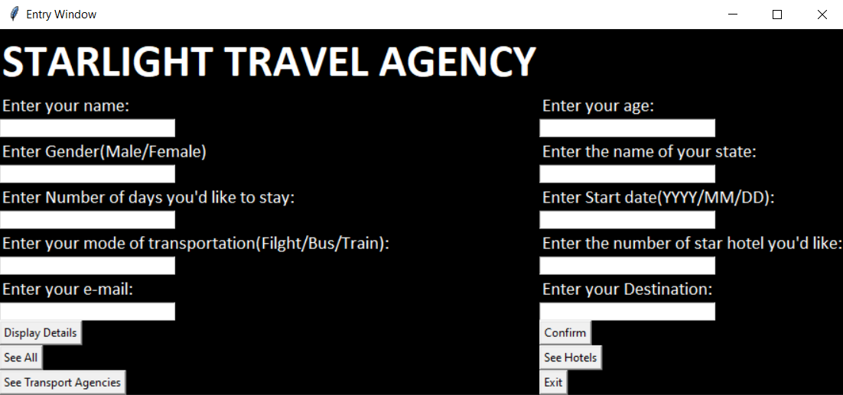The Main GUI screen and Python Shell when Main.py is executed

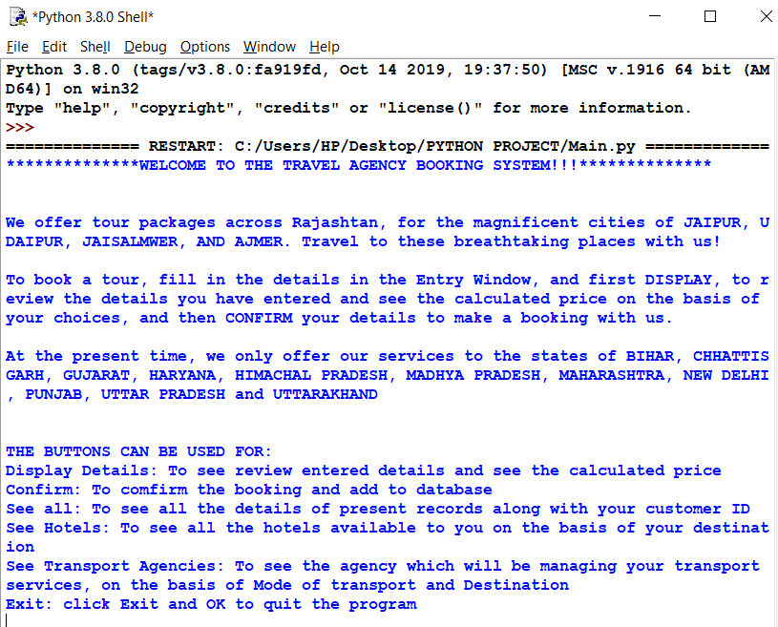

* 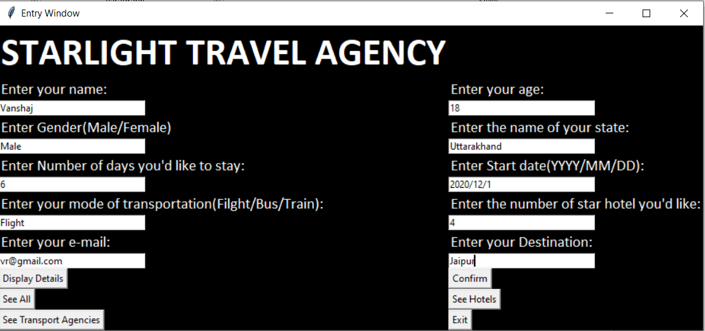**Entering some details in the GUI interface**
* **Entered some records using Confirm Button, and now output of Display Details Button**

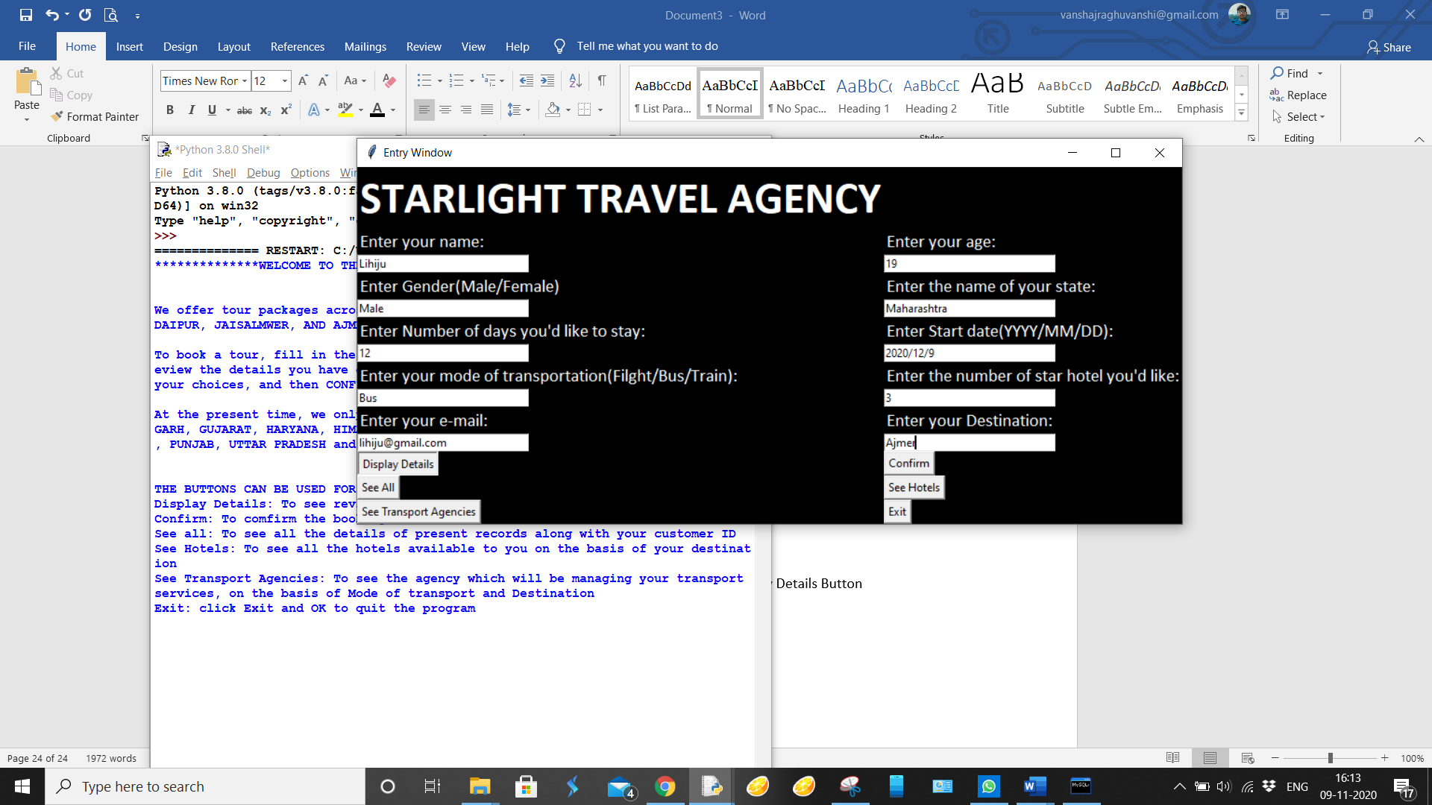



* 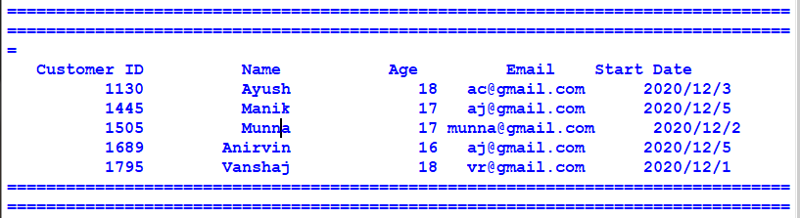**Output on using See All Button**
* **Output on using See Hotels Button, taking input too**

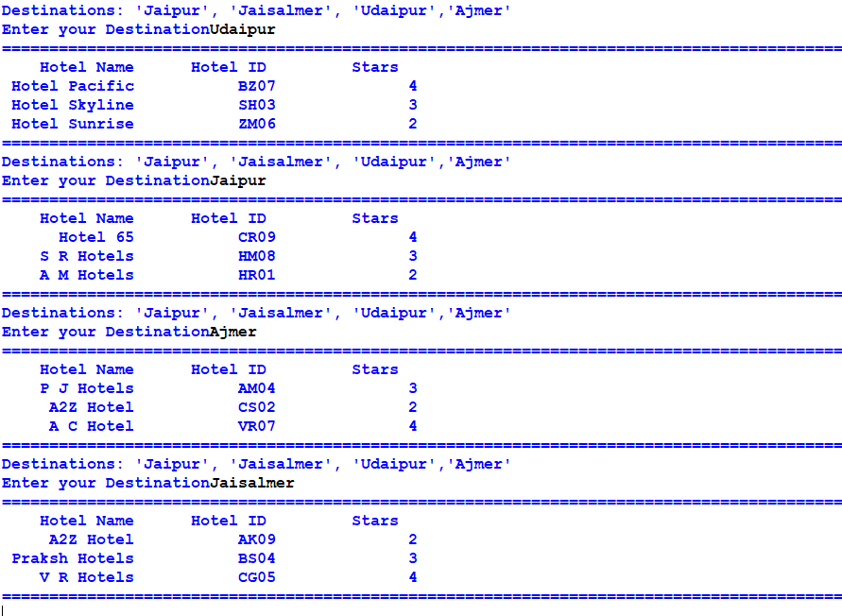

* **Some outputs on using See Transport Agencies Button, and giving input**

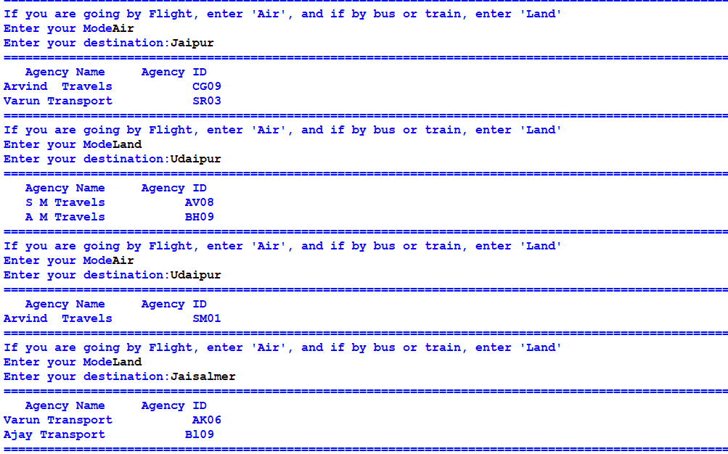

* 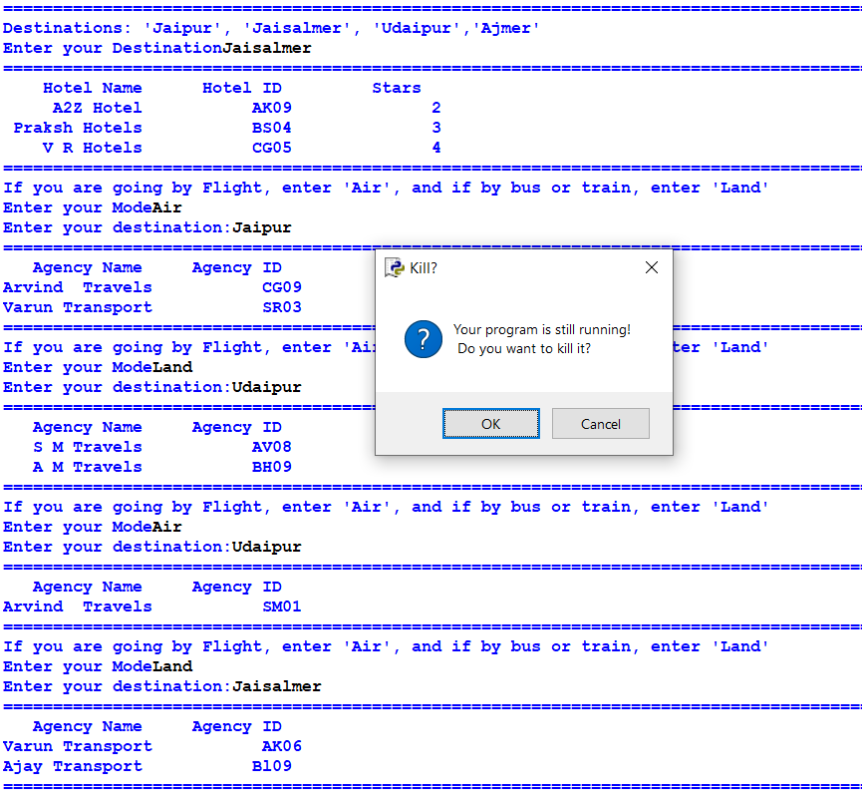**Output on clicking Exit Button**

**LIMITATIONS**

* Only one record can be Entered at a time
* Program is case sensitive
* Program is only applicable to a limited number of states
* Dependency on modules

**REQUIREMENTS**

* Hardware Configuration:
* *Processor :* Intel Pentium Or Equivalent And Above
* *Memory :* 2 GB Ram
* *Hard disk :* 1 GB Free Space
* Software Configuration:
* *Platform :* Windows 7 Or Later
* *Database :* MySql

**BIBLIOGRAPHY**

* [**www.stackoverflow.com**](http://www.stackoverflow.com)
* [**www.geeksforgeeks.com**](http://www.geeksforgeeks.com)
* [**https://youtu.be/YXPyB4XeYLA**](https://youtu.be/YXPyB4XeYLA)
* [**https://youtu.be/_lSNIrR1nZU**](https://youtu.be/_lSNIrR1nZU)
* [**www.tutorialspoint.com**](http://www.tutorialspoint.com)